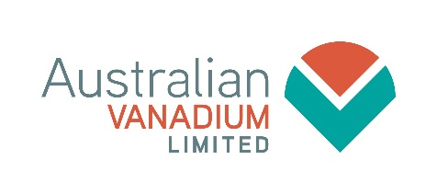
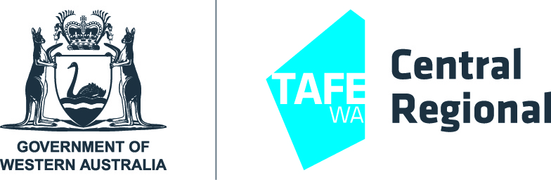

2022 Australian Vanadium Limited
Mullewa Scholarship Program (Application Form)

Central Regional TAFE and Australian Vanadium Ltd are offering a $500.00 scholarship opportunity to full-time students residing in Mullewa, during semester one and two, 2022.

The successful applicants will receive a scholarship to the value of $500.00. The funds will be applied to course fees in the first instance; the remainder may be used for future training, resource fees or other costs at the recipient’s discretion.

Applicants are strongly encouraged to learn about Australian Vanadium Ltd and the significant contribution they will make to the region. www.australianvanadium.com.au

Application Process
- Application forms should be completed with as much detail as possible.
- To be eligible, application forms are required to be submitted, prior to the closing date for each semester.
- Central Regional TAFE staff may assist students in completing the application form, if required.
- Completed application forms must be submitted to the Student Services reception area.
- Checklist: Please ensure you have completed all items, prior to submitting your application.

Awarding the Scholarships
- Scholarships are awarded to successful applicants, via a selection process.
- The successful applicants will receive financial assistance, to a maximum of $500.00, which will be paid once the recipient has met the following criteria:
- Approved enrolment in an eligible course at Geraldton campus;
- Attendance and participation in the course is confirmed; and
- If the student withdraws from the course, within the first six weeks, the amount of scholarship paid towards fees will not be returned to the student, it will be returned to the scholarship budget.
- To support regional students, if the student requires the scholarship funds to pay their residential accommodation, Central Regional TAFE will pay this directly (TAFE residential or private accommodation).

Selection process
- A selection panel is formed to consider applications.
- Applications are ranked, via a selection matrix, based on the information provided.
- Applicants’ referees may be contacted for further information about the applicant.
- Applicants may be contacted by phone, if the panel requires additional information.
- Short-Listed applicants are interviewed by a selection panel and asked a range of questions, relating to their application, current and future study, community involvement and employment goals.

Further assistance from Central Regional TAFE Staff:
- Coordinator Student Support Services- (08) 9956 6140.
- Aboriginal Student Support Coordinator- (08) 9956 2775.

2022 Australian Vanadium Limited Scholarship Program (Application Form)

STUDENT DETAILS

Name:
Address:
Daytime Phone: |  |  | Mobile:
Email:

Which course are you currently enrolled in?

EDUCATIONAL HISTORY

Please list previous studies, training or courses previously undertaken.
Course: |  | Training Provider/School: | Result:

ADDITIONAL AWARDS, PRIZES OR ACHIEVEMENTS

Please list any additional activities resulting in awards, prizes, recognition or achievements.

Examples: Sporting or community service awards, special recognition by an employer, acknowledgement for volunteer work.
Achievement: |  | Organisation:

- QUESTIONS
- Please provide an outline of your future goals. Examples: Study / training/ employment / family / travel / volunteering
- What do you know about Australian Vanadium Limited and the organisation’s activities and services?
Tip: research the sponsor for further information

- Please tell us a little about yourself.
Examples: Family / special interests / personal qualities / long term goals / inspirational people / skills or talents

- Please provide an outline of the community issues or activities that interest you.
Examples: Community working together/ youth/ education/ training/ employment/ housing/ justice/ health/ sport/ family/ arts

- Please provide a brief explanation of how this scholarship may benefit you.
Examples: It will help me financially to…/ it will give me an incentive to continue studying in … / I would use it to…
- Is your resume attached? Yes No If No, please complete the blank resume available from Student Services.
- Please list 2 referees
NOTE: Only list your referees once, in either this application or on your resume.
- Name | Phone Number:
- Name: | Phone Number:

- Do you want to add any other supporting information (including documents) for your application? (OPTIONAL)
Examples: Current work undertaking/ pathways undertaking to get to where you are...

- Have you previously received, or are you currently in receipt of, a scholarship of any type? Yes No
If Yes, please provide the following information
Name of scholarship: | Year: | Value:

- Checklist
Information read by applicant Application form completed (including signature)
Resume attached Referees listed

- Return your completed application to: Student Support Services
In Person: | Central Regional TAFE Student Services, X Block, 175 Fitzgerald Street GERALDTON
Post: | Central Regional TAFE  ‘Scholarship Program’ Attn: Student Support Services  Locked Bag 103 | GERALDTON WA 6531
Email: | student.services@crtafe.wa.edu.au

APPLICANT SIGNATURE
Student Signature: | Date:
Application Closing Dates
Semester One- Friday 11th March 2022 @ 4pm
Semester Two- Friday 26th August 2022 @ 4pm

